**Low Level Design (LLD)**

**PRESCRIPTION LABEL READING**



**Revision Number - 1.0**

**Last Date of Revision – 02-10-2023**

# Document Control

| **Date** |  | **Version** | **Description** | **Author** |
| --- | --- | --- | --- | --- |
| 02-10-2023 | 1.0 |  | LLD documents | Asif Ali  Hiren Thakkar  Khushwant Singh  Sanket Maheta  Shritama Sengupta  Shreya Mohanty |

**Contents**

Document Version Control…………………………………………………………………………2

1. Introduction……………………………………………………………………………………….4
   1. What is Low Level Design Document?.................................................................4
   2. Scope……………………………………………………………………………………4
   3. Project Introduction……………………………………………………………………4
2. Problem Statement.……………………………………………………………………………...5
3. Dataset Information……………………………………………………………………….……...5
4. Architecture…………………………………………………………………………………….…6

# 1. Introduction

## 1.1 What is Low Level Design Document?

The objective of the Low-level design document (LLDD) is to provide the internal logic design of the Heart Disease Diagnostic Analysis dashboard's actual programme code. Class diagrams with methods and relations between classes and programme specifications are described by LLDD. It describes the modules, allowing the programmer to create the programme directly from the document.

**1.2 What is Scope?**

Low-level design (LLD) is a refinement-based, component-level design method. The method can be used to create data structures, the necessary software architecture, source code, and ultimately performance algorithms. Overall, the data organisation may be defined and refined during requirement analysis and data design, respectively.

## 1.3 Project Introduction

* Supporting elderly or vulnerable patients should be a priority for numerous organisations.
* Enabling voice messages can facilitate elderly individuals' comprehension of your message.
* Text-to-Speech can give you peace of mind by enabling you to provide superior service.
* You could even send voice messages that read prescription labelling, This is notably true for health care professionals.
* for instance.
* This can be quite problematic for those with reading difficulties, let alone the elderly and visually impaired.
* A label that speaks and is sent directly to your device makes it simple to learn everything about your medication.
* Additionally, dosage data can be monitored and shared with carers..

# 2. Problem Statement

You must extract the textual information from the prescriptions and convert it to speech using OCR techniques.

You must develop a solution that recognises and identifies the text in prescriptions and reads the names of medications and dosage limits to visually impaired patients.

# 3. Dataset Information:

Captured images are uploaded to the model.

# 4. Architecture

## 4.1 Architecture Description

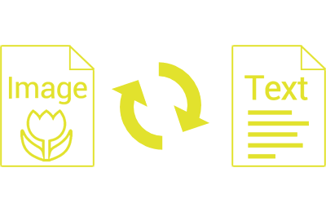

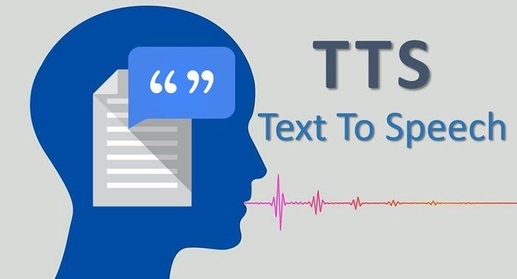

.

### Reporting

Reporting is the most essential and undervalued skill in the field of data analytics. As a Data Analyst, you should be adept at producing simple and self-explanatory reports, as your model will be utilised by numerous non-technical stakeholders.

1. High Level Design Document (HLD)
2. Low Level Design Document (LLD)
3. Architecture
4. Wireframe
5. Detailed Project Report
6. Power Point Presentation